COMMISSIONERS:

Mark A. Talbott
Chairman

Wesley H. Woodham
Secretary

Steve Carter
Treasurer

Paul Hazucha

Ex-Officio:
Charles S. Wiggins
Fire Department Chief

Mailing Address:
5408 Mulat Rd
Milton, FL 32583

Main Firehouse:
5408 Mulat Road
Milton, Florida
32583

E-mail:
info@avalonfirerescue.com

Website:
www.avalonfirerescue.com

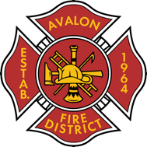

AVALON FIRE/RESCUE DISTRICT
A fire protection and rescue district re-authorized by Session Law 2005-347

AGENDA

Commissioners Meeting

September 16, 2024

@ 7:00pm Avalon Fire Rescue Station

- Treasurer’s Report
  - Invoices V-01 to V-18
  - Bank balances
  - Rhonda Alexander has terminated her contract
- 2024 E-1 ENGINE
- AT&T Fiber
  - Installation is happening this week
- New Volunteer
- Oath of Office – Steve Carter
- 24/25 Budget Review
- Public Open Forum

Next meeting 10/7/2024

