COMMISSIONERS:

Mark A. Talbott
Chairman

Wesley H. Woodham
Secretary

Steve Carter
Treasurer

Paul Hazucha

Ex-Officio:
Charles S. Wiggins
Fire Department Chief

Mailing Address:
5408 Mulat Rd
Milton, FL 32583

Main Firehouse:
5408 Mulat Road
Milton, Florida
32583

E-mail:
info@avalonfirerescue.com

Website:
www.avalonfirerescue.com

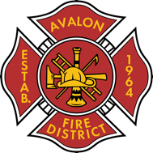

AVALON FIRE/RESCUE DISTRICT
A fire protection and rescue district re-authorized by Session Law 2005-347

AGENDA

Commissioners Meeting

September 19, 2024

@ 7:30pm Avalon Fire Rescue Station

- 24/25 Budget Approval

Next meeting 10/7/2024

