COMMISSIONERS:

Mark A. Talbott
Chairman

Don Galbraith
Secretary

Steve Carter
Treasurer

Paul Hazucha

Ex-Officio:
Charles S. Wiggins
Fire Department Chief

Mailing Address:
5408 Mulat Rd
Milton, FL 32583

Main Firehouse:
5408 Mulat Road
Milton, Florida
32583

E-mail:
info@avalonfirerescue.com

Website:
www.avalonfirerescue.com

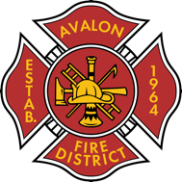

AVALON FIRE/RESCUE DISTRICT
A fire protection and rescue district re-authorized by Session Law 2005-347

AGENDA

Commissioners Meeting

April 21, 2025

@ 7:00pm Avalon Fire Rescue Station

- Treasurer’s Report
  - Invoices
  - Balances on Accounts
  - P&L
  - Budget v Actual
- Chief’s Report
- Open Public Forum

Next meeting 05/5/2025

