COMMISSIONERS:

Mark A. Talbott
Chairman

Wesley H. Woodham
Secretary

Steve Carter
Treasurer

Paul Hazucha

Ex-Officio:
Charles S. Wiggins
Fire Department Chief

Mailing Address:
5408 Mulat Rd
Milton, FL 32583

Main Firehouse:
5408 Mulat Road
Milton, Florida
32583

E-mail:
info@avalonfirerescue.com

Website:
www.avalonfirerescue.com

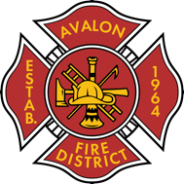

AVALON FIRE/RESCUE DISTRICT
A fire protection and rescue district re-authorized by Session Law 2005-347

AGENDA

Commissioners Meeting

August 19, 2024

@ 7:00pm Avalon Fire Rescue Station

- Treasurer’s Report
  - Invoices paid T-01 to T-21
- New Truck
  - Contract out to LLW for review
- Fence Status
  - Waiting on new gates
- The1st Bank
  - Adding Steve Carter to account
- Public Open Forum

Next meeting 09/2/2024

