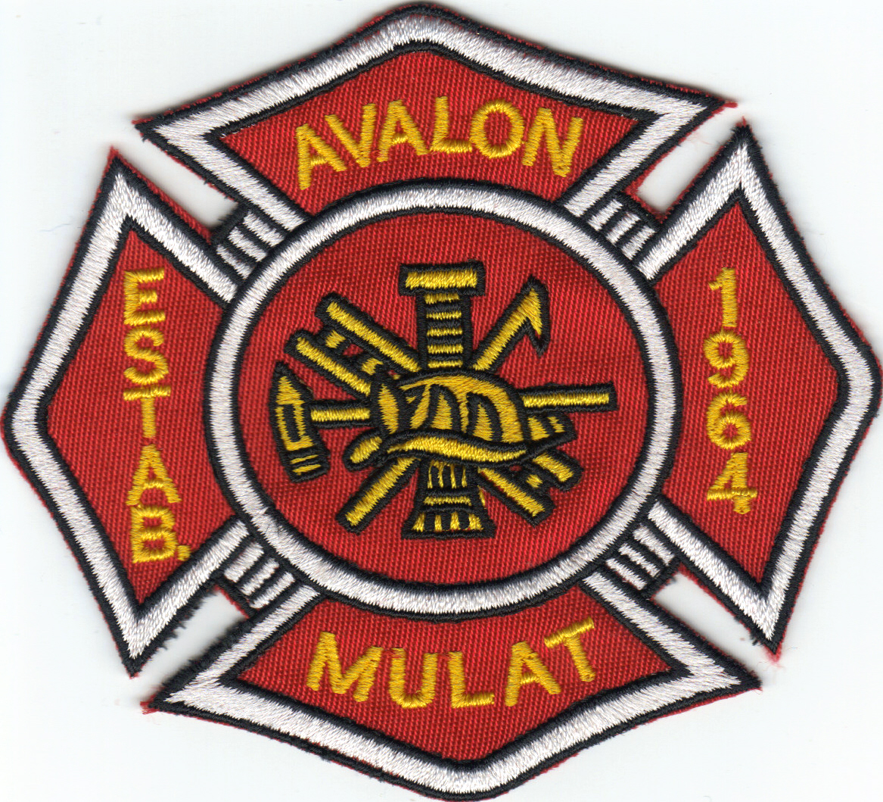 Avalon Fire Rescue 

Application for Membership
Note: Application must be filled out completely. Do not remove any of the pages of this application. Applications expire six (6) months from date of submittal. Applicants must reapply to maintain an active application.
Please Return to:
Avalon Fire Rescue
5408 Mulat Road
Milton, FL 32583
Phone: (850) 994-4445 Fax: (850) 994-8681

Type of Membership Application:
□ Volunteer Firefighter
□ Junior Firefighter (must be a minimum age of16 years old to apply)
Note: Release to be signed by parent or legal guardian and notarize. Application will not be accepted until completion and receipt of this release.

PERSONAL INFORMATION
Last Name First Name Middle Name

Address: City State Zip Code
E-mail Address: Social Security Number
_______/______/__________
Telephone Number: _________________  Cell Number: _____________________  Alternate Number: _____________________ |  |  |  |  |  |  | Date of Birth ____________
Driver’s License: □ Yes □ No  License #: _______________________ |  |  |  |  |  |  | State Issued: _____________  Issue Date: _________ Expiration Date:________
EDUCATION
Check Highest Grade Completed: □ 8 □ 9 □ 10 □ 11 □ 12 □ GED or Equivalent
Check Highest College Grade Completed: □ 1 □ 2 □ 3 □ 4 Graduate Studies: □ Yes □ No
College or  University | Location |  |  |  |  |  |  |  | Degree Type  And Major  (e.g. BA, BS) |  |  | Degree Earned?
 |  |  |  |  |  |  |  |  |  |  |  | □ Yes □ No
 |  |  |  |  |  |  |  |  |  |  |  | □ Yes □ No
 |  |  |  |  |  |  |  |  |  |  |  | □ Yes □ No
 |  |  |  |  |  |  |  |  |  |  |  | □ Yes □ No
CERTIFICATES AND LICENSES
Note: Please provide copies of all Certificates/License
Type: State:  Certificate/License #: |  |  |  | Date Issued: |  |  |  | Date Expires: |  |  | Issuing Agency:
Type: State:  Certificate/License #: |  |  |  | Date Issued: |  |  |  | Date Expires: |  |  | Issuing Agency:
Type: State:  Certificate/License #: |  |  |  | Date Issued: |  |  |  | Date Expires: |  |  | Issuing Agency:
Type: State:  Certificate/License #: |  |  |  | Date Issued: |  |  |  | Date Expires: |  |  | Issuing Agency:
Office/Computer Skills:

Other Skills:

SPECIALIZED SKILLS – Check Skills
Provide License/Certificate Information Above
Microsoft Word |  |  |  |  |  | Emergency Medical Technician or Paramedic
Microsoft Excel |  |  |  |  |  | First Responder
Microsoft PowerPoint |  |  |  |  |  | Certified Firefighter I or II
Grant Writing
REFERENCES
List three (3) references, excluding relatives, you have known for more than 5 years

Name |  | Address |  |  |  |  |  |  | Telephone  Number |  | Relationship to you
1.
2.
3.
EMPLOYMENT EXPERIENCE

Start with your present or last job. Include any job-related military service assignments and volunteer activities.
1. Employer |  |  | Dates Employed  From: To: |  |  |  |  |  |  | May we Contact? □ Yes □ No
Street Address |  |  |  |  | City |  |  |  |  | State |  |  | Zip
Telephone Number(s) |  |  |  |  |  |  |  |  |  | Hours Worked per week:
Job Title:

Duties:

Supervisor:
Reason for Leaving:
2. Employer |  |  | Dates Employed  From: To: |  |  |  |  |  |  | May we Contact? □ Yes □ No
Street Address |  |  |  |  | City |  |  |  |  | State |  |  | Zip
Telephone Number(s) |  |  |  |  |  |  |  |  |  | Hours Worked per week:
Job Title:
Duties:

Supervisor:
Reason for Leaving:
3. Employer |  |  | Dates Employed  From: To: |  |  |  |  |  |  | May we Contact? □ Yes □ No
Street Address |  |  |  |  | City |  |  |  |  | State |  |  | Zip
Telephone Number(s) |  |  |  |  |  |  |  |  |  | Hours Worked per week:
Job Title:
Duties:

Supervisor:
Reason for Leaving:
FIREFIGHTER SUPPLEMENTAL QUESTIONAIRE

1. Are you 18 years old or older? □ Yes □ No

2. Are you a citizen of the U.S.? □ Yes □ No

3. How long have you lived in this fire district?

_________Years _______ Months

4. Do you have a valid Commercial Driver’s License (CDL?) □ Yes □ No

5. Have you received any traffic citations in the past 3 years? □ Yes □ No

If yes, please indicate type(s) and date(s): _____________________________________________

6. Have you (since the age of 18) ever been convicted of or plead guilty or no contest to a misdemeanor? □ Yes □ No

If yes, please describe the circumstances:

7. Have you (since the age of 18) ever been convicted of or plead guilty or no contest to a felony?
□ Yes □ No

If yes, please describe the circumstances:

8. Do you have any medical problems? □ Yes □ No
Note: A physical may be required prior to membership acceptance.

If yes, please explain:

9. Are you able to work well as a team and work well with others? □ Yes □ No

10. Do you have time to be a Volunteer Firefighter? □ Yes □ No
Note: There are many hours of training mandated by the state and minimum department call and meeting percentages that have to be met to remain as an active member.

11. Do you have any Firefighting Experience? □ Yes □ No
Note: If you have this experience, please indicate how much experience you have and where you obtained this experience. (Make sure this experience is listed in your work history section above as well).

Amount of Experience: ________________________________________________________

Previous Department Name: ________________________________

Address of Previous Department: ____________________________________________

Previous Department Contact Name and Phone Number: _______________________________

EMERGENCY CONTACT INFORMATION
In Case of Emergency:

Primary Contact Name: ____________________________________________

Contact Phone Number(s): Home: _________________________Cell: _____________________

Work: ________________________________ Alternate: _________________________

Relationship of Emergency Contact: _______________________________________________

Secondary Contact Name: ____________________________________________

Contact Phone Number(s): Home: _________________________Cell: _____________________

Work: ________________________________ Alternate: _________________________

Relationship of Emergency Contact: _______________________________________________

APPLICANT’S STATEMENT
I certify that answers given herein are true and complete to the best of my knowledge. I authorize investigation of all statements contained in this application for membership as may be necessary. I also give permission to conduct Background Check, Drivers License Check and Employment Verifications as indicated in those sections of the application.

This application for membership shall be considered active for a period of time not to exceed 180 days. Any applicant wishing to be considered as a member beyond this time period should inquire as to whether or not applications are being accepted at that time.

In the event of membership or employment, I understand that false or misleading information given in my application or interview(s) may result in discharge or dismissal from Avalon Fire Rescue Dept. I understand, also, that I am required to abide by all rules and regulations adopted by the Avalon Fire Rescue District.

______________________________________________ _________________________
Signature of Applicant Date

Department Use Only – Do Not Write In this Area:

Date Application Received ________________

Picture Taken? □ Yes □ No

Date Reviewed by Board: ___________________

Accepted?? □ Yes □ No

If not accepted, reason: ________________________________________________________

____________________________________________________________________________

Copy provided to Chief? □ Yes □ No

Background, Drivers License and Employment Check

Background Check Completed □ Yes □ No

Date of Background Check: _______________________________________

Driver’s License Check: □ Yes □ No

Date of Driver’s License Check: _______________________________________

Employment Check: □ Yes □ No

Date of Employment Check: _______________________________________

Document any issues or findings below from checks above:

Date of Discussion with Chief: _____________________

Date Appointed by Chief: __________________________

Application Process

1) Application to be completed and received by Avalon Fire Rescue Fire Dept.

2) Application will be reviewed by the Membership Committee for completeness. The membership committee will contact the applicant to schedule a time schedule Board meeting is generally the first Thursday of every month.

4) If recommended by the Membership Committee, the application will be forwarded to the Board of Trustees and Chief for review and final approval.

5) When approved, the Chief will contact you directly.

During the application process, you are welcomed and encouraged to attend training sessions and meetings.

If you have any questions about this application or have not heard back regarding status within 30 days, please contact Chief Sid Wiggins at 850-516-5642.

