COMMISSIONERS:

Mark A. Talbott
Chairman

Wesley H. Woodham
Secretary

Steve Carter
Treasurer

Paul Hazucha

Ex-Officio:
Charles S. Wiggins
Fire Department Chief

Mailing Address:
5408 Mulat Rd
Milton, FL 32583

Main Firehouse:
5408 Mulat Road
Milton, Florida
32583

E-mail:
info@avalonfirerescue.com

Website:
www.avalonfirerescue.com

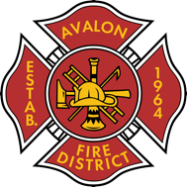

AVALON FIRE/RESCUE DISTRICT
A fire protection and rescue district re-authorized by Session Law 2005-347

AGENDA

Commissioners Meeting

October 21, 2024

@ 7:00pm Avalon Fire Rescue Station

- Treasurer’s Report
  - Invoices X-01 to X-
- Additional accounts for Deployment Expenses & Reimbursement in FY24-25 have been created
- Make a decision on Regions Bank
- Florida Commerce
  - New Registered Agent is needed – currently Rodney Johnson is listed
- Hurricane Milton Deployment
- Public Open Forum

Next meeting 11/04/2024

